**Day-3. Assignment on pointers**

**1.** C Program to Display Prime Numbers Between Intervals Using Function

Enter two positive integers: 12

30

Prime numbers between 12 and 30 are: 13 17 19 23 29

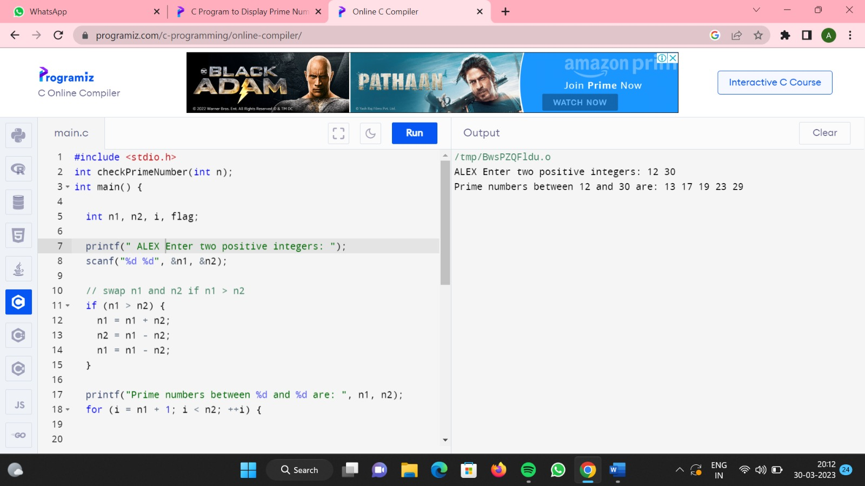

**2.** C Program to Check Whether a Number can be Expressed as Sum of Two Prime Numbers

This program takes a positive integer from the user and checks whether that number can be expressed as the sum of two prime numbers.

If the number can be expressed as the sum of two prime numbers, the output shows the combination of the prime numbers.

Enter a positive integer: 34

34 = 3 + 31

34 = 5 + 29

34 = 11 + 23

34 = 17 + 17

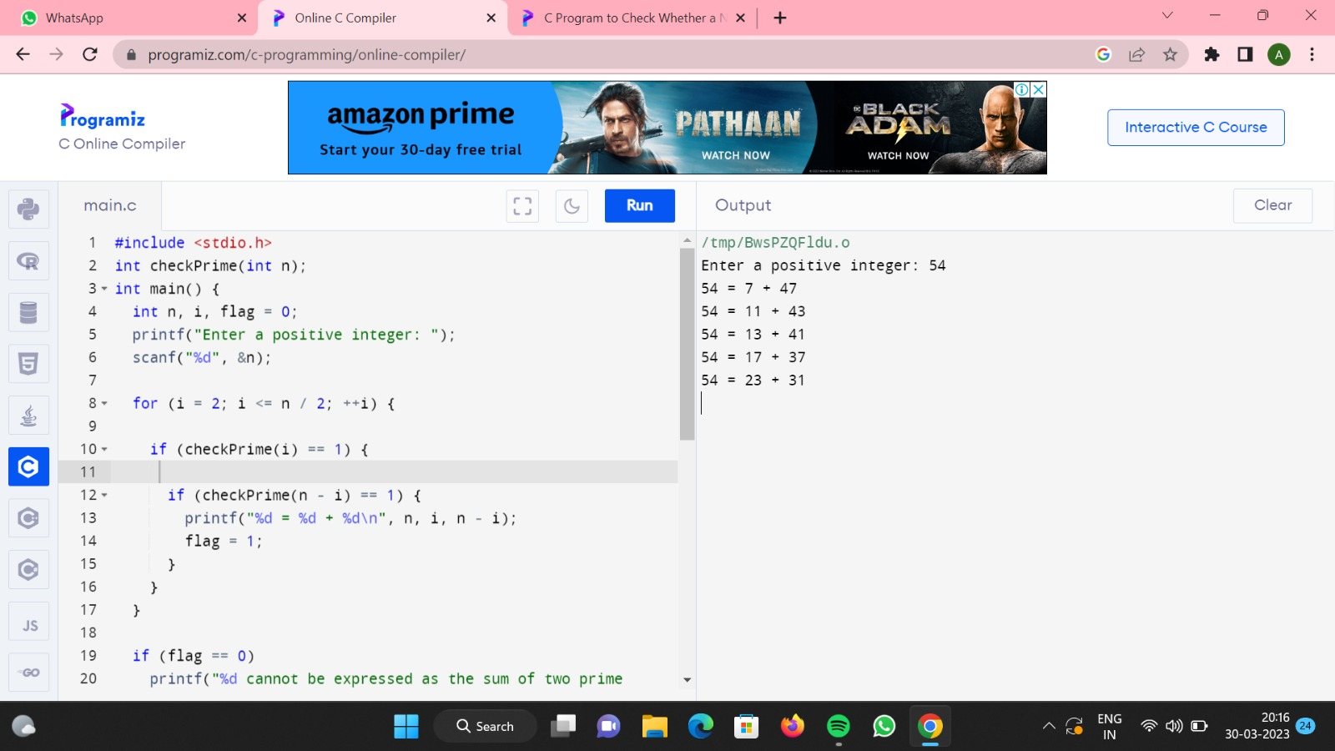

3. C Program to Find GCD of Two Numbers using Recursion

**Problem Description**

This C program, using recursion, finds the GCD of the two numbers entered by the user.

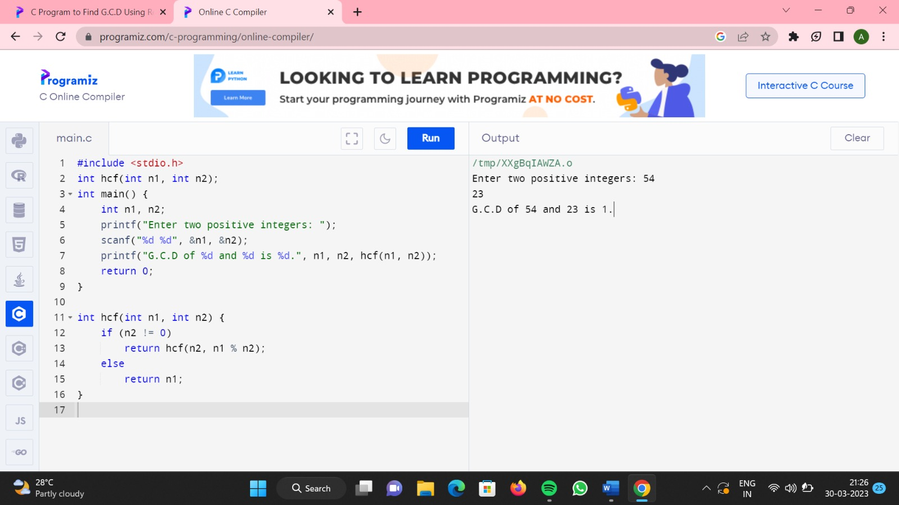

4. C Program to Find LCM of Two Numbers

**Problem Description**

Write a C program to find the LCM of two numbers.

What is LCM (Least Common Multiple)?  
LCM stands for Least Common Multiple. It is a method to find the lowest common multiple between the two numbers.  
LCM of two numbers is the lowest possible number that is divisible by both numbers.

Examples: LCM (10,15) = 30, LCM(18,26) = 234.

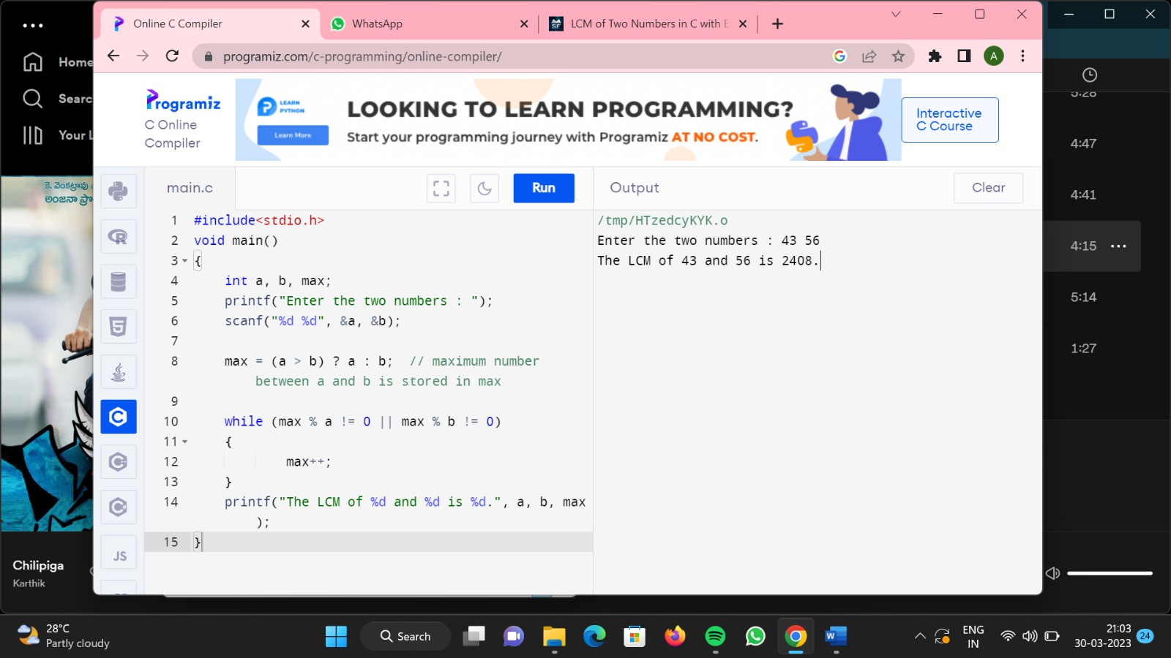

5. C Program to Find Highest Frequency Character in a String

Enter a string : Welcome to Sanfoundry's C Programming Class !

Max repeated character in the string = o

It occurs 4 times

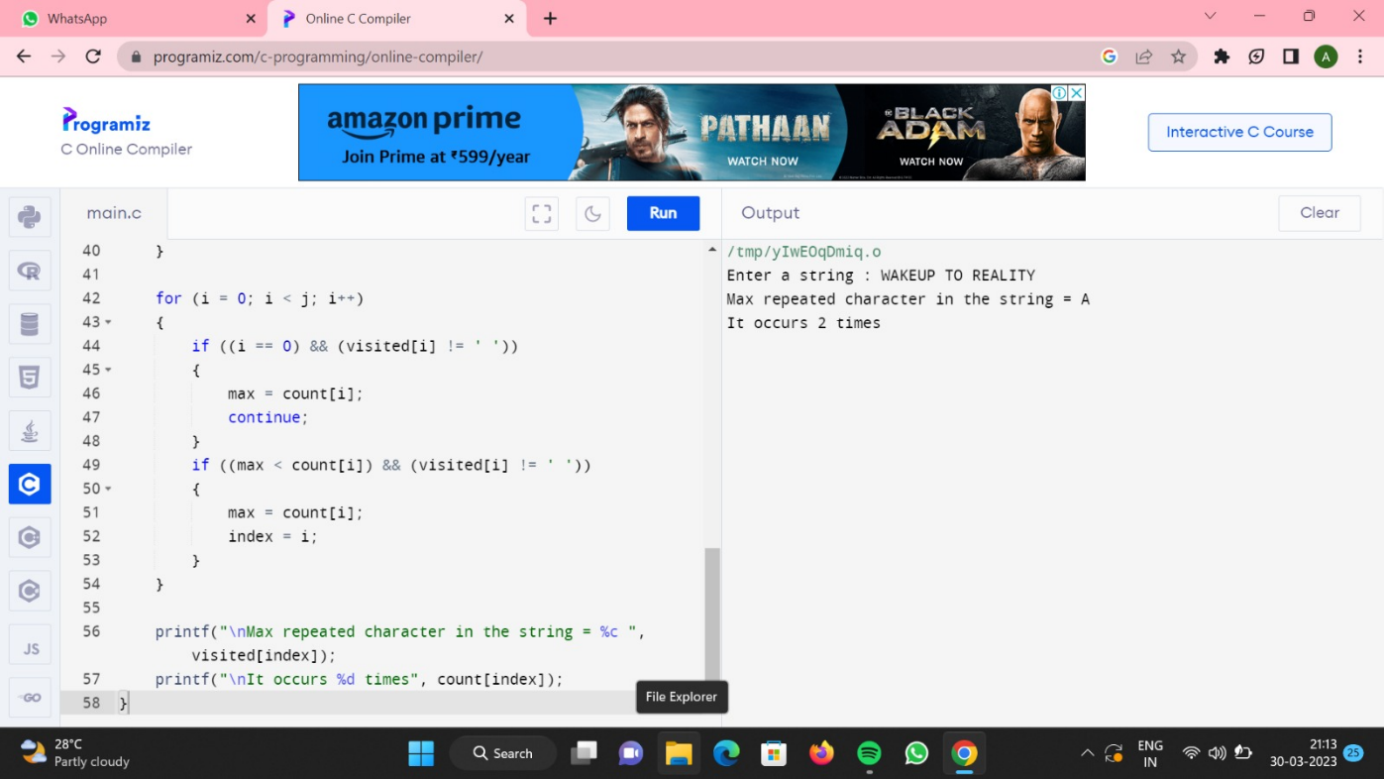

6. **Anagram Program in C**: Two strings are said to be **anagrams** if they satisfy two conditions, the length of both strings must be equal to each other and second the strings must have the same set of characters.

**Example 1:**

**First String** = “hectare” and **Second String** = “teacher”

**Case 1:**  
Lengths must be equal to each other.  
length of “hectare” = 7  
length of “teacher” = 7  
Case 1 passed.

**Case 2:**  
Set of characters in  
hectare {‘h’ , ’e’ , ’c’ , ’t’ , ’a’ , ’r’ , ’e’}  
teacher {‘t’ , ’e’ , ’a’ , ’c’ , ’h’ , ’e’, ’r’}

Every character from the first string has a similar character to it in the other string. Case 2 passed.

”teacher” and ”hectare” are anagrams.

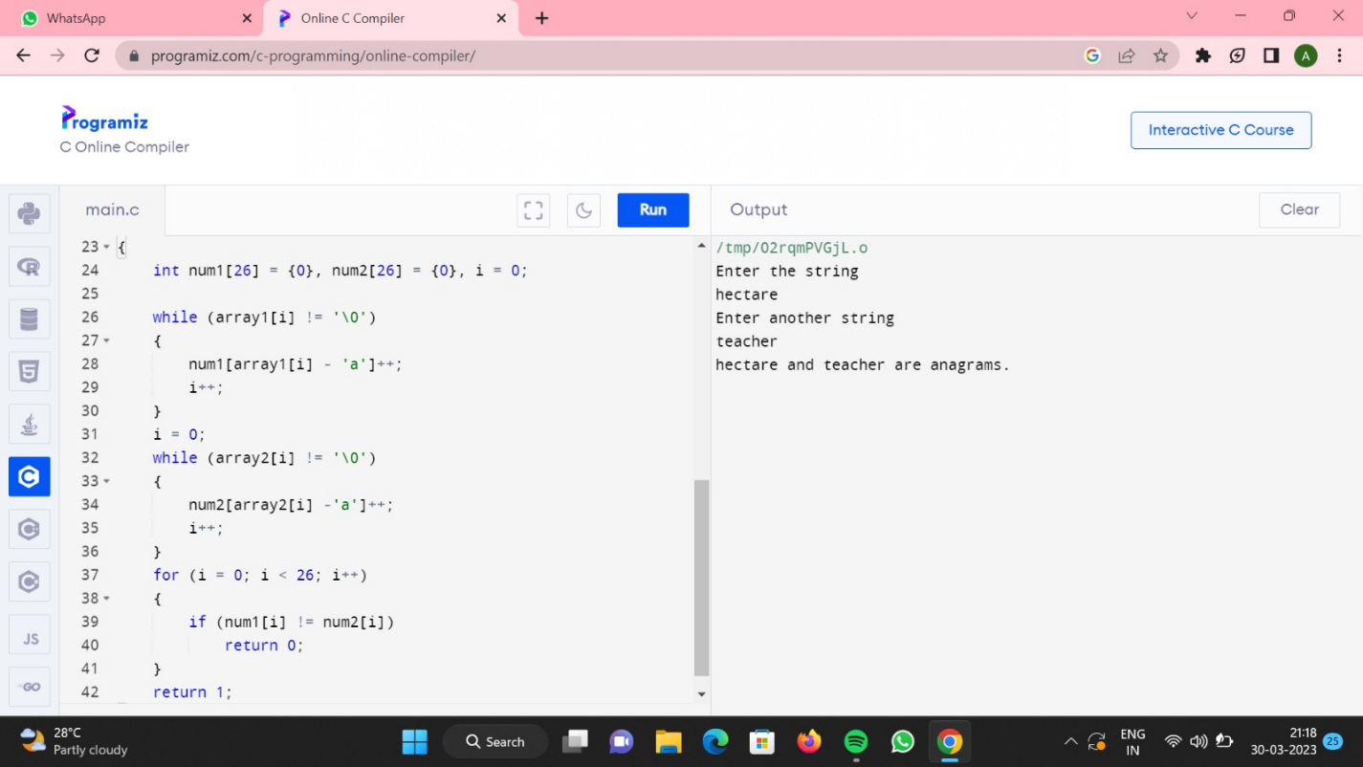

7. C Program to Find the Sum of ASCII Value of All Characters in the String

**Problem Description**

This program takes a string as input and finds the sum of ASCII values of all characters in a given string.

**Sample Input / Output**

Enter the string : Welcome to Sanfoundry's C Programming Class, Welcome Again to C Class !

Sum of all characters : 6307

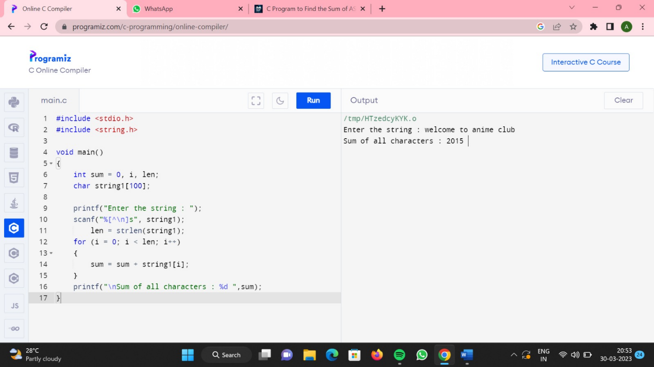

8. C Program to Print All Permutations of a Given String

Enter a string: SAN

All possible permutations are:

SAN

SNA

ASN

ANS

NAS

NSA

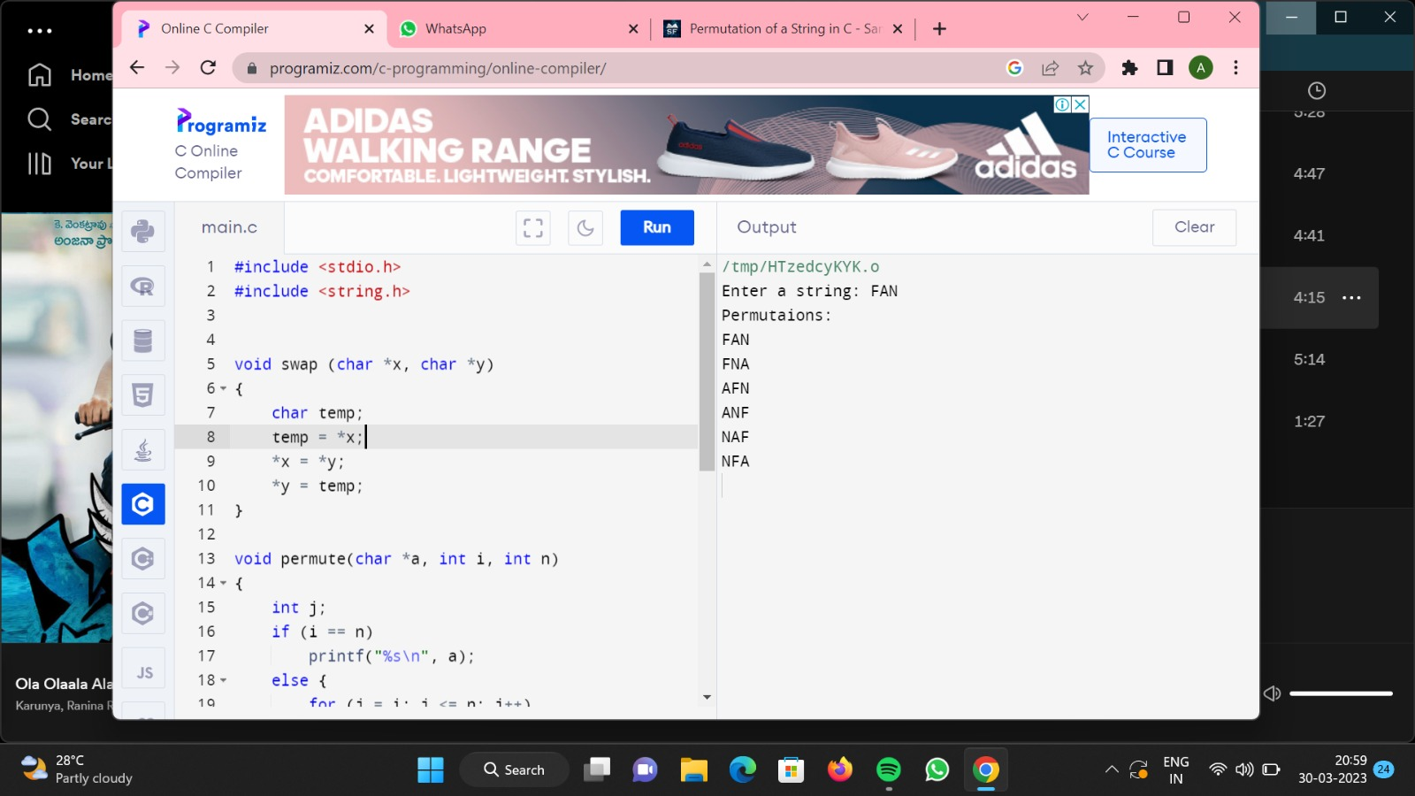

9. Write a C program to copy one array elements to another array using pointers. How to copy array elements from one array to another array using pointers. Logic to copy one array to another array using pointers in C programming.

**Example**

**Input**

Input array1 elements: 10 -1 100 90 87 0 15 10 20 30

**Output**

Array1: 10 -1 100 90 87 0 15 10 20 30

Array2: 10 -1 100 90 87 0 15 10 20 30

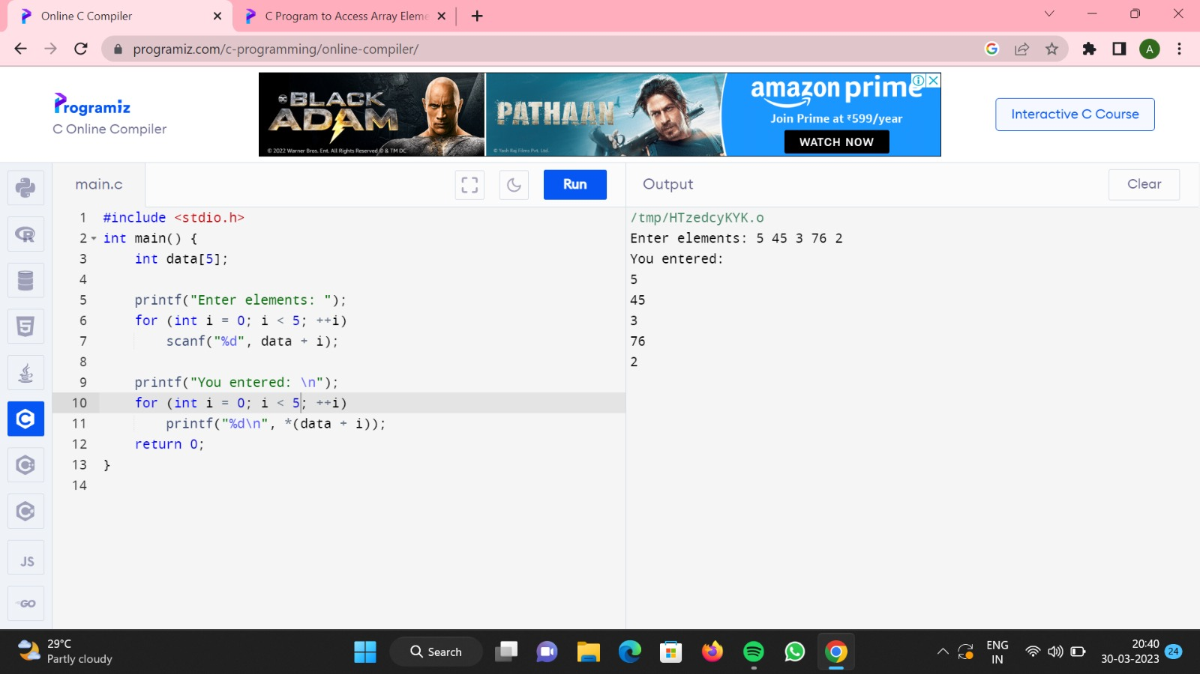

10. Write a C Program to reverse string using pointers and function.

Enter any String :: Saveetha

The Reverse of the String [ Saveetha ] is :: ahteevaS

